

Diamond Valley Early Learning Centre’s Annual Walking Field Trips
DVELC is located in the Turner Valley United Church at 125 Royal Avenue
Turner Valley School Playground and Field (located across the street at 114 Royal Avenue)
Sheep River Library & Millennium Park (located at 129 Main Street)
Spray Park (located at 207 Main Street behind Dr. Lander Memorial Swimming Pool)
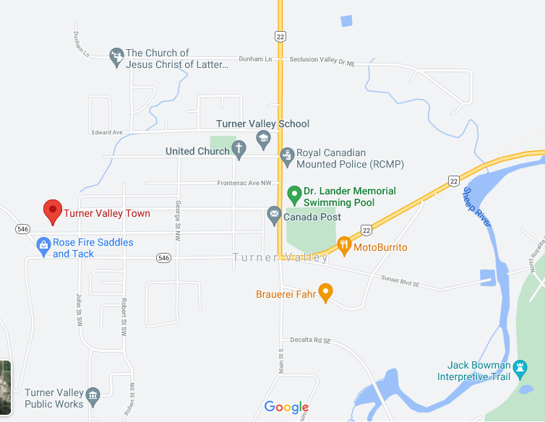
Neighbourhood walk route (south on Hubert, East on Edgar, North on Hwy 22, West on Royal or the same route opposite directions)

